Question 2
Part-a
Note: $Pr\left(L ≤ 10\right)=0.90$ and $Pr\left(L ≤ 20\right)=0.96$
$${VaR}_{0.95}=inf\left(x: Pr\left(L ≤ x\right)≥0.95\right)$$
$=20$
${CVaR}_{0.95}\left(L\right)=\frac{\left(20×0.06\right)+\left(100×0.04\right)}{0.06+0.04}=52$

Part-b
$${VaR}_{β}=F^{-1}\left(β\right)$$
$1-e^{-x}=β$ (solve for $x$)
$$e^{-x}=1-β$$
$$x=-ln\left(1-β\right)$$
So ${VaR}_{β}=-ln\left(1-β\right)=ln\left(\frac{1}{1-β}\right)$
$${CVaR}_{β}\left(L\right)=\frac{1}{1-β}\int_{ln\left(\frac{1}{1-β}\right)}^{∞}{x f\left(x\right) dx=\frac{1}{1-β}{\left[-\left(x+1\right)e^{-x}\right]}_{ln\left(\frac{1}{1-β}\right)}^{∞}}$$
$=\frac{1}{1-β}\left[0+\left(ln\left(\frac{1}{1-β}\right)+1\right)\left(1-β\right)\right]$
$=ln\left(\frac{1}{1-β}\right)+1$

Part-c
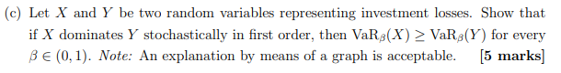
Since X dominates Y stochastically in first order, then
$$F_{X}\left(t\right)≤F_{Y}\left(t\right)$$
Note that ${VaR}_{β}\left(X\right)={F^{-1}}_{X}\left(β\right)$ so the area to the left of $β$ under the pro
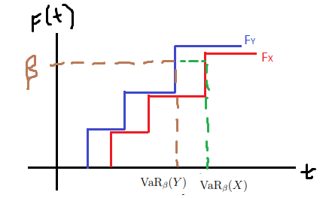
which shows ${VaR}_{β}\left(X\right)≥{VaR}_{β}\left(Y\right)$

Question 2
Part-d ( Part-i )
Note that ${CVaR}_{β}\left(L\right)$ is the expected loss among the worst $100\left(1-β\right)\%$ of outcomes while ${VaR}_{β}\left(L\right)$ is the best outcome among the worst $100\left(1-β\right)\%$ of outcomes
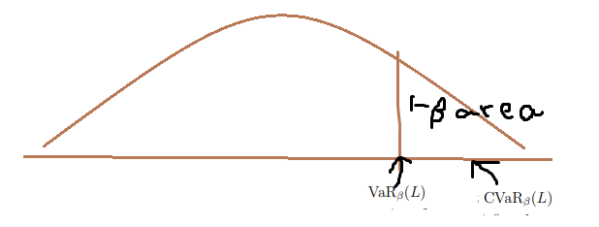

Question 1
Part-a-i
Later

Part-a-ii
Probability that all n roads from A to B are blocked = $p^{n}$
The probability that at least one roads from A to B is not blocked is ${=1-p}^{n}$
The probability that at least one roads from B to C is not blocked is ${=1-p}^{n}$
By independence, the probability that there is an open road from A to C is
$=\left({1-p}^{n}\right)\left({1-p}^{n}\right)$ or ${\left({1-p}^{n}\right)}^{2}$

Part-b
Let $E_{1}=$ event that at least one roads from A to B is not blocked
$E_{2}=$ event that at least one roads from B to C is not blocked
$E_{3}=$ event that the direct road from A to C is not blocked
We know $P\left(E_{1}\right){=1-p}^{n}$ and $P\left(E_{2}\right){=1-p}^{n}$ from previous calculations
We need to consider 2 cases
Case # 1: The direct road from A to C is blocked and it has probability $p$
We calculate $P\left(E_{1} ∩ E_{2}\right)=P\left(E_{1}\right) P\left(E_{2}\right)={\left({1-p}^{n}\right)}^{2}$ by independence
Case # 2: The direct road from A to C is not blocked and it has probability $1-p$
By conditioning, the required probability is ${\left({1-p}^{n}\right)}^{2}p + \left(1-p\right)$

Part-c
By cdf technique,
$$P\left(Y≤y\right)=P\left(max\left(X_{1},X_{2},...,X_{n}\right)≤y\right)$$
$=P\left(X_{1}≤y, X_{2}≤y ,...,{ X}_{n}≤y \right)$
$=P\left(X_{1}≤y \right)P\left(X_{2}≤y \right)∙∙∙P\left({ X}_{n}≤y \right)$ by independence
$=y∙y∙∙∙y$ Note that there are n factors
$=y^{n}$
The CDF of Y is $F_{y}\left(y\right)=\left\{\begin{matrix}1 & , if y≥1 \\ y^{n} & , if 0 < y < 1 \\ 0 & , if y≤0\end{matrix}\right.$
Differentiating the CDF will give the PDF
$$f_{y}\left(y\right)=ny^{n-1} , for 0<y<1$$

Part-d
We want to solve $r$ in the equation
$$-10+\frac{6}{1+r}+\frac{8}{{\left(1+r\right)}^{2}}=0$$
$$\frac{6}{1+r}+\frac{8}{{\left(1+r\right)}^{2}}=10$$
Multiply both sides by ${\left(1+r\right)}^{2}$
$$6\left(1+r\right)+8=10{\left(1+r\right)}^{2}$$
$$6+6r+8=10r^{2}+20r+10$$
$$10r^{2}+20r+10=6r+14$$
$$10r^{2}+14r-4=0$$
$$5r^{2}+7r-2=0$$
By quadratic formula
$$r=\frac{-7+\sqrt{7^{2}-4\left(5\right)\left(-2\right)}}{2\left(5\right)}=\frac{-7+\sqrt{89}}{10}≈0.2434$$
The IRR is 24.34%

Question 4
Part-a
$$E\left(ξ\right)=w_{1} E\left(ξ_{1}\right)+w_{2} E\left(ξ_{2}\right)=w_{1}+{2w}_{2}=w_{1}+2\left({1-w}_{1}\right) =2-w_{1}$$
So $2-w_{1}=γ$ and $w_{1}=2-γ$ and $w_{2}=γ-1$
$$Var\left(ξ\right)={w_{1}}^{2} Var\left(ξ_{1}\right)+{w_{2}}^{2} Var\left(ξ_{2}\right) + 2w_{1}w_{2}\left(-0.5\right)$$
$={w_{1}}^{2} Var\left(ξ_{1}\right)+{w_{2}}^{2} Var\left(ξ_{2}\right) + 2w_{1}w_{2}\left(-0.5\right)$
$={\left(2-γ \right)}^{2} +{\left(γ-1\right)}^{2} - \left(2-γ \right)\left(γ-1\right)$ because $Var\left(ξ_{1}\right)=Var\left(ξ_{2}\right)=1$
$=3γ^{2}-9γ+7$
$$\frac{d Var\left(ξ\right)}{d γ}=6γ-9$$
Equate the derivative to zero so $γ=1.5$
Note that when $γ=1$, $Var\left(ξ\right)=3{\left(1\right)}^{2}-9\left(1\right)+7=1$
when $γ=2$, $Var\left(ξ\right)=3{\left(2\right)}^{2}-9\left(2\right)+7=1$
when $γ=1.5$, $Var\left(ξ\right)=3{\left(1.5\right)}^{2}-9\left(1.5\right)+7=0.25$
We conclude that $γ=1.5$ minimizes the portfolio variance

Question 4
Part b
$E\left[X\right]=px_{1}+\left(1-p\right)x_{2}$ so $u\left(E\left[X\right]\right)=u\left(px_{1}+\left(1-p\right)x_{2}\right)$
$$E\left[u\left(X\right)\right]=p∙u\left(x_{1}\right)+\left(1-p\right)∙u\left(x_{2}\right)$$
It is given that $u\left(E\left[X\right]\right)≥E\left[u\left(X\right)\right]$
It follows that
$$u\left(px_{1}+\left(1-p\right)x_{2}\right)≥p∙u\left(x_{1}\right)+\left(1-p\right)∙u\left(x_{2}\right)$$
The right side of the inequality represents the y-coordinate of a point on a straight line joining $\left(x_{1},u\left(x_{1}\right)\right)$ and$\left(x_{2},u\left(x_{2}\right)\right)$ and the left side represents the corresponding y-coordinate of this point on the curve. The inequality says that the line joining the two points at $x_{1}$ and $x_{2}$ is below the curve and we can illustrate by the graph below. The second derivative of the graph is negative as illustrated below
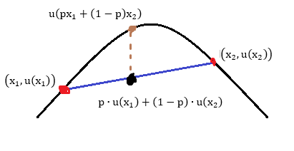

Question 4 (cont)
Part-c-Part-i
Let $k=$ amount of insurance
Expected Cost without insurance: $0\left(0.90\right)+100\left(0.09\right)+1000\left(0.01\right)=19$
Expected Cost wit insurance: $k\left(0.90\right)+\left(k+100\right)\left(0.09\right)+\left(k+200\right)\left(0.01\right)=k +11$
We want
$$k +11≤19$$
$$k ≤8$$
The maximum amount of insurance we are willing to pay is 8

Question 4 (cont)
Part-c-Part-ii
Without insurance, the loss of expected utility is
${\left(0/100\right)}^{2}\left(0.90\right)+{\left(100/100\right)}^{2}\left(0.09\right)+{\left(1000/100\right)}^{2}\left(0.01\right)=1.09$
With insurance, the loss of expected utility is
${\left(0.01k\right)}^{2}\left(0.90\right)+{\left(0.01k +1\right)}^{2}\left(0.09\right)+{\left(0.01k + 2\right)}^{2}\left(0.01\right)=0.0001k^{2}+0.0022k+0.13$
We want $0.0001k^{2}+0.0022k+0.13≤1.09$
$$0.0001k^{2}+0.0022k-0.96≤0$$
$$k^{2}+22k-9600≤0$$
Using quadratic formula to solve for $k^{2}+22k-9600=0$, we have
$$k=\frac{-22+\sqrt{{22}^{2}-4\left(1\right)\left(-9600\right)}}{2\left(1\right)}=\frac{-22+\sqrt{{22}^{2}-4\left(1\right)\left(-9600\right)}}{2\left(1\right)}≈87.60$$
The maximum amount of insurance we are willing to pay is 87.60

